**I. Python Programs**

1. Write a PYTHON program to print ‘n’ number.
2. Write a PYTHON program to sort 12, -9,6,8 and -100.
3. Write a PYTHON program to convert 145 days into months and days.
4. Write a PYTHON program to find sum of n numbers.
5. Write a PYTHON program to find the largest and smallest numbers from the given ‘n’ numbers.
6. Write a PYTHON program to calculate Factorial of a number.
7. Write a Python program to calculate area of rectangle by using Function.
8. Write a Python program to find the length of the string
9. Write a Python program to check if a given string starts with a given substring.
10. Python program to count Even and Odd numbers in a List
11. Write a python program to Reverse words in a given String
12. Python program to print even length words in a string
13. Write a PYTHON program to concatenate two strings using string handling functions.
14. Write a Program to display count, from 5 to 15 using python loop.
15. Write a python program to create the following pattern using for loops

*****

****

***

**

*

and

*

**

***

****

*****

**II. Libre Office**

1. Create a power point presentation in Libre Office
2. Create a chart in libre office calc
3. Start LibreOffice Writer, create a new document and type some text in the document. Perform numbering styles in the document using LibreOffice Writer. Save the file.
4. Start LibreOffice Writer, create a new document and type some text in the document. Checking Spelling and Grammar Using LibreOffice Writer. Save the file
5. Start LibreOffice Writer, create a new document and type some text in the document. Perform calc basic operations like SUM, AVERAGE, COUNT and MAX. Using LibreOffice Writer. Save the file.
6. Start LibreOffice Writer and perform mail merge operation.

**III.PHP**

1. Write a PHP program which adds up columns and rows of given table.
2. Write a PHP program to compute the sum of first 10 given prime numbers.
3. Write a PHP program to find largest and smallest number from 100, 205, 345, 465, 565, 676, 777, 869, 999
4. Write a PHP program to create mark table with 3 subjects and print only the list of students who secured less than 40 in all 3 subjects.
5. Write a PHP code to create a student mark sheet table. Insert, delete and modify records.
6. Write a PHP script to read the current directory and return a file list sorted by last modification time.
7. Write a PHP program to calculate the mod of two given integers without using any inbuilt modulus operator
8. PHP Programs for printing pyramid patterns
9. PHP program to check whether the given number is even or not.
10. Write a simple calculator program in PHP using switch case.
11. Write a PHP program to show day of the week based on numbers using switch/case statements.
12. Write a PHP program to check student grade based on the marks using if-else statement.
13. Write a PHP program to calculate Factorial of a number using recursive function.

**IV. Graphviz**

1. Draw the following graph using Graphviz

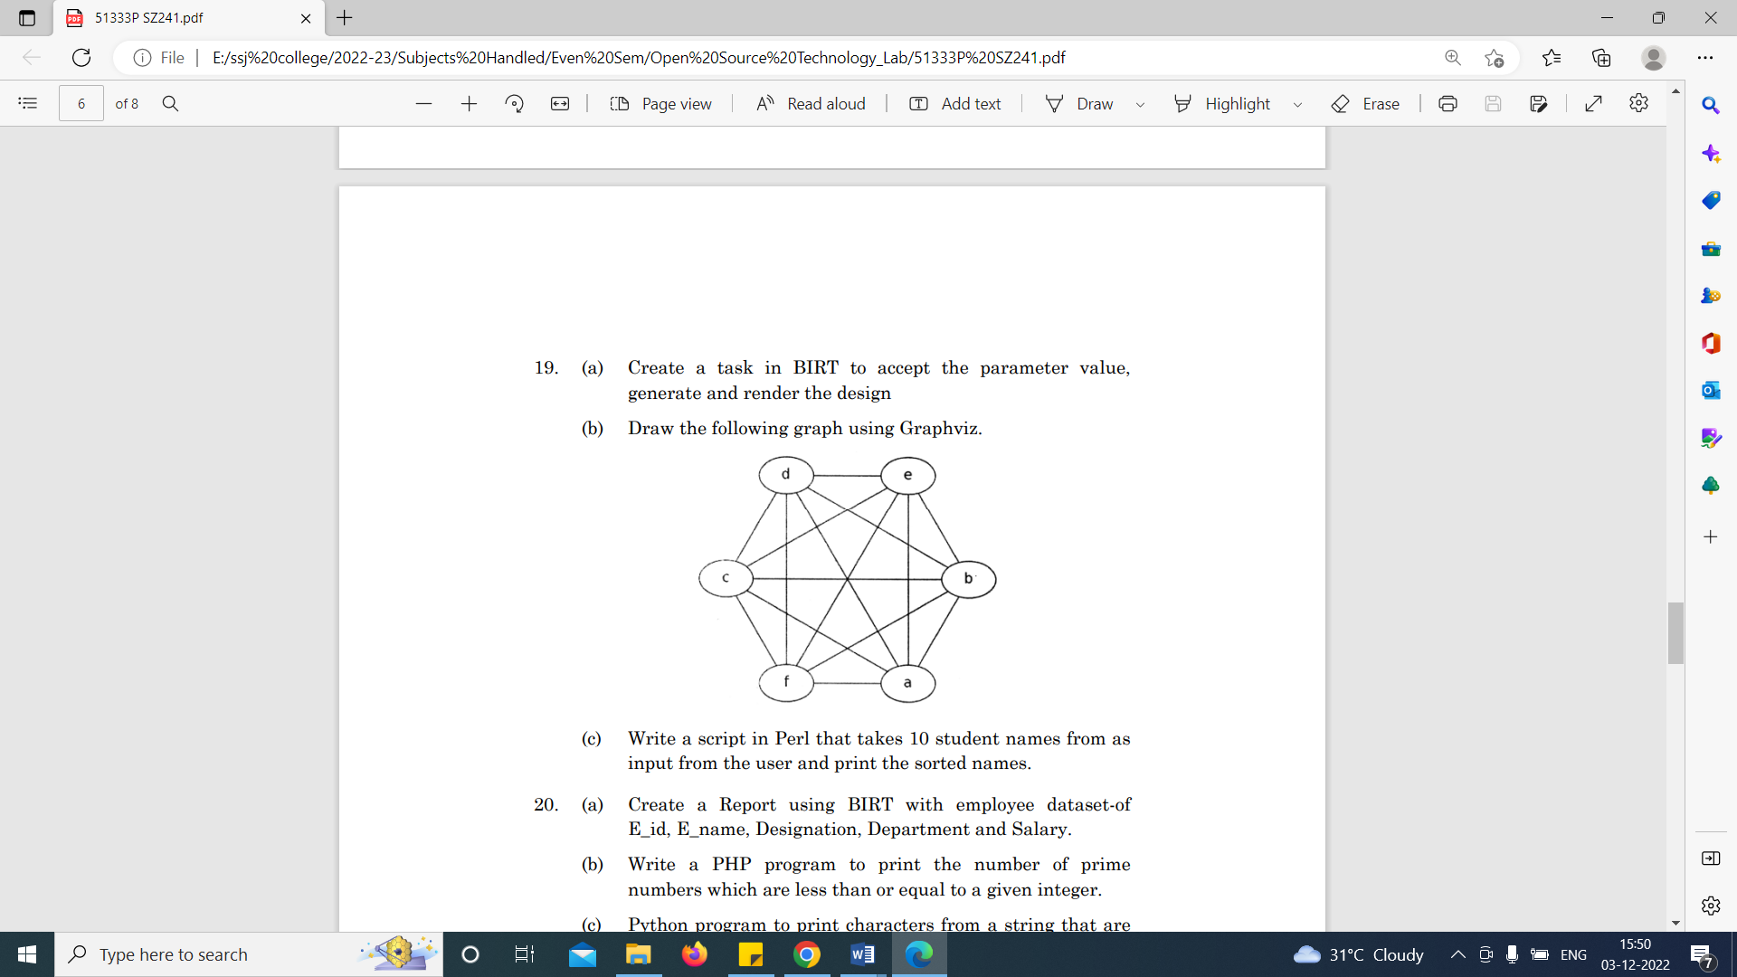

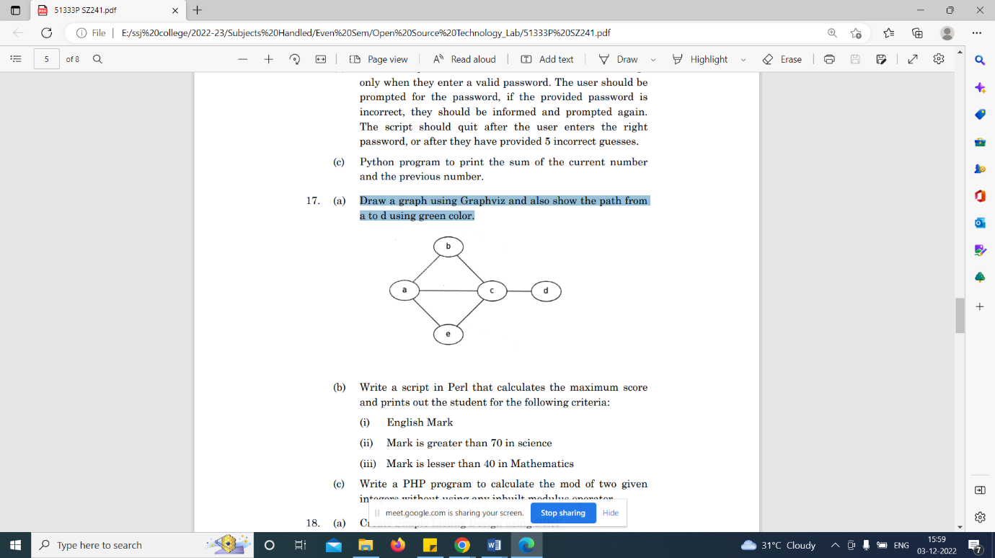2. Draw a graph using Graphviz and also show the path from a to d using green color.

**V. Perl Scripts**

1. Write a script in Perl to find the answer of the following equation where n = 5

n/2[ 2a + (n -1)d]

2. Write a script in Perl to find the answer of the following equation where a = 3 and b = 2. a3+3a2+3ab2 + b2.

3. Write a script in Perl that calculates the maximum score and prints out the student for the following criteria:

(i) English Mark

(ii) Mark is greater than 70 in science

(iii) Mark is lesser than 40 in Mathematic

4. Write a script in Perl that takes 10 student names from as input from the user and print the sorted names.

**VI. GIT**

1. Perform version control using GIT.

2. Create a GIT control system to access the old code.

3. Creation of commit file using GIT.

4. Create a repo on GitHub that contains a markdown file with question and answer.

5. Do the following using Git. Also create a new directory, init command for repository, and Create a README file

6. In GIT use the commit command to commit the contents of the staging area. Create a src directory and add a couple of files to it.

7. In GIT use the log command in order to see all of the commits you made so far. Also use the show command to look at an individual commit.

**VII. GIMP**

1. Image manipulation using GIMP.

2. Edit gif image using GIMP

**VIII. BIRT**

1. Create a task in BIRT to accept the parameter value, generate and render the design

2. Use BIRT to generate a report for 10 students in alphabetical order

**IX. JMagallanes**

1. Use random data to develop a chart using the business tool JMagallanes

**X. Steps to install Linux OS**

**XI. Software Config uration in Linux environment.**